Assignment 0 – Mukesh Ravichandran - 50380788

Apache Spark Installation on my MAC

Java Installation
Apache Spark runs on java, so installation of JAVA SDK , Since my PC Is M2 MAC 2022 ,
I will have to choose ARM64 which fits for my macOS.

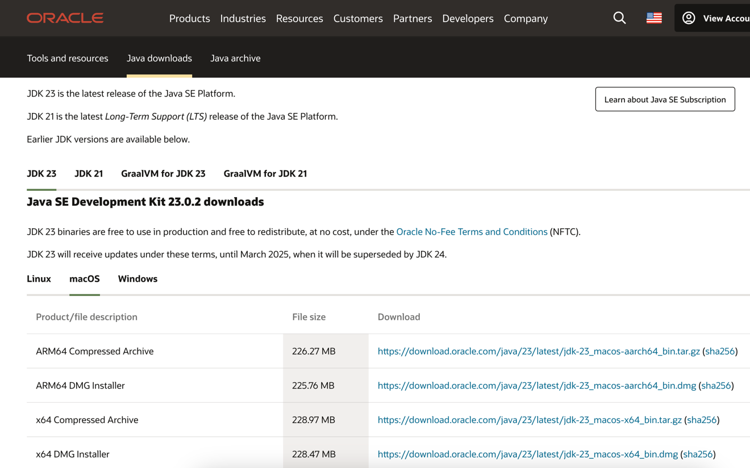
Figure 1 - Website->Java Downloads->latest version->ARM64 DMG Installer

Java Installation
Now open the downloads and just follow the next steps, it will automatically do the rest of the installation , once installed , you may move the installer to trash .
Go to terminal and type the command
“ java –version”
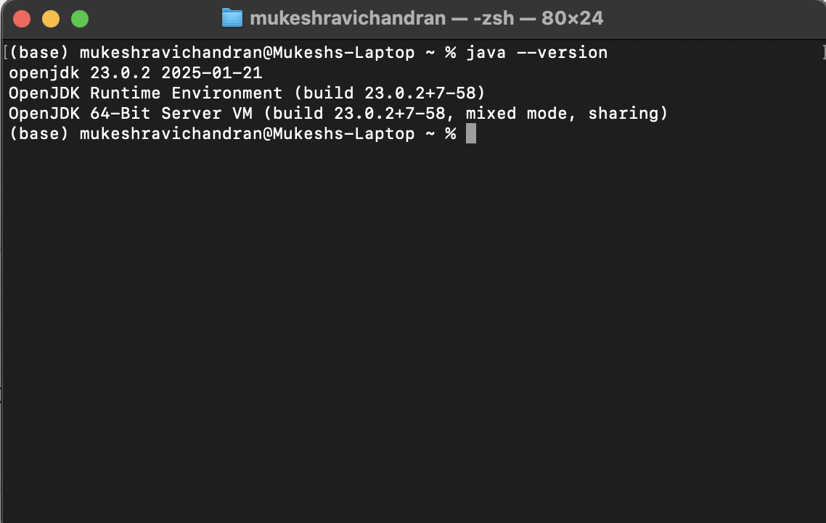
Figure 2- Terminal display of JAVA 23 version on mac

Download Apache SPARK
Go to apache spark downloads, , choosing the latest release and package type and download the .tgz file .
I was pondering what is this new file type , I understood later that
A .tgz file is a compressed archive that combines multiple files into one using TAR (Tape Archive) and then compresses them using Gzip (.gz).

